Smart Doc Application

Application Deployment Instructions

Below is the configuration of the application and instructions to be followed to deploy the application

# Infrastructure Configuration

|  |  |  |  |  |
| --- | --- | --- | --- | --- |
| IDE | Database | Web Server | Java Version |  |
| **Eclipse** | MySQL 8.0.19 | Tomcat 9 | Java 1.8.0_26 |  |

## External Jars list

Below are the external jars required to execute this application,

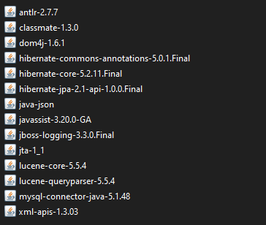

All the above required jar files are zipped and attached below



# Database Information

## Required Database tables

Below are tables used in this application

jdbc: mysql://localhost:3306/smartdoc

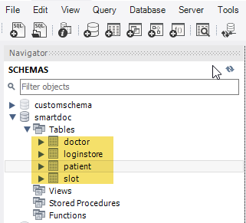

To connect to the database from application, I have used the default “username/password” as “root/password”.

This is hardcoded in the “hibernate.cfg.xml” and if you have a different username and password, be sure to change these values in the hibernate configuration XML file.

## Create Table scripts

To hold the data in the application we need to create database tables in MySQL database before we deploy the application



## Insert Table scripts

To hold the default data in some of tables, we need to execute the insert script in mysql database tables before we deploy the application,



# Web page login

After the deployment is completed in tomcat server, please use the below URL to login to the application

<http://localhost:8080/SmartDoc/loginpage.jsp>

